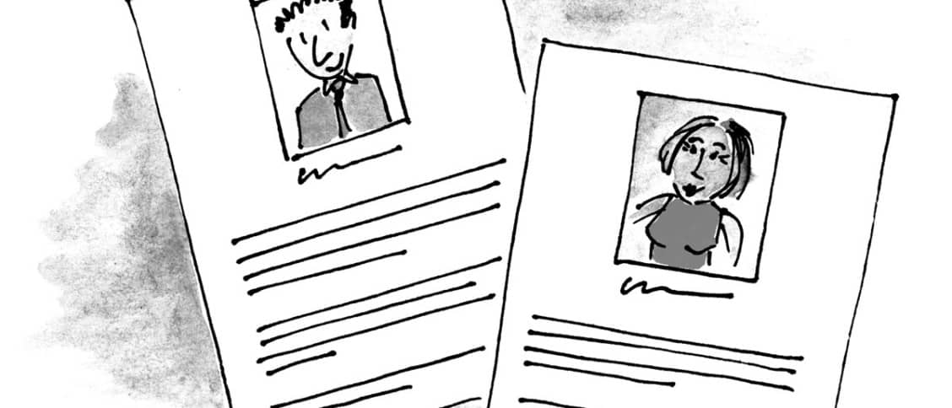

*personas*

persona is a **profile.** A character sketch. An approximation of a segment of your product users or target market. If you think them in terms of archetypes, personas require you to look at who yours user actually are kinds of users you would like to focus on and create a set of archetypes for the broad profile any one of your users might fit at any given time.

while there is some argument against the effectiveness of personas as a tools in UX design mainly sue to their common, but avoidable pitfalls the value of placing your users front and center is clear:

personas generate empathy and empathy is essential to the DNA of UX design. Personas allow you to look at a personal representation of your users and come to a better understanding of what your real users needs and goals look like in real moments of their lives.

No matter what kind of personas you choose to employ more on that in a moment, if you’re making a focused and systematic. effort to keep your users at the heart of every design decision you make you’ll end up with a better product all around.

Personas are also helpful as your design team presets solutions to clients and stakeholders, telling users stories to keep

them at the center of Design making

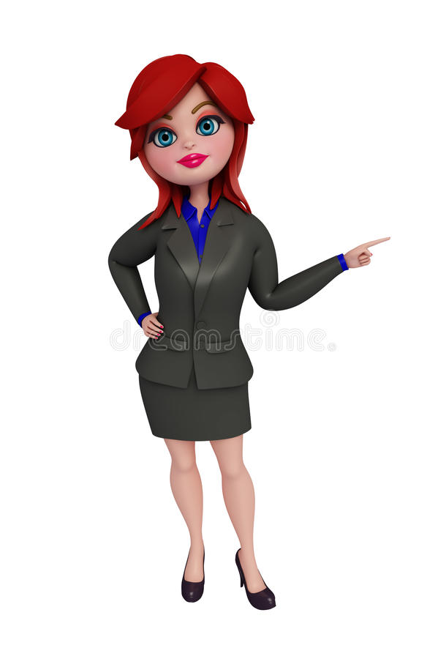**A UX persona’ s profile Includes:**

**A fictional: name**

**A photo**

**An occupation**

**Demographics (age, location, marital, status, relative income, etc)**

**Goals and needs**

**pain points**

**Relevant patterns of behaviors**

**A personality (can be reflected using quotes)**

**Examples Of UX Personas**

Typical UX persona 1:

John, an entrepreneur

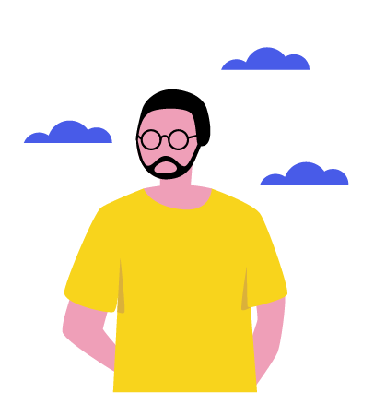 **Fictional Name**: mugen

**Occupation:** self-employed , owns a cake shop in the city

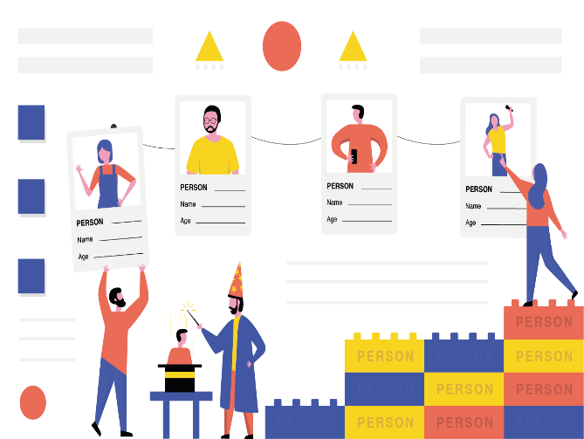 **Demographics :**

* 31 years old
* Lives in Washington;
* Married, no children
* Has two brothers
* Take care of his father after a stroke, helps him out financially
* Has an upper -middle -income level & a profitable business.

**Goals and needs**

As a busy person, mugen doesn’t like wasting time as time is money for him. He needs to make payments n-the-go and have access to most banking service. like generating banking services like generating banking documents, applying for loans, etc

.being a business owner. he needs to keep his business banking account and a personal one separate .simultaneously. john wants to use both account easily and switch between them with no effort

**Pain points**

Switching between different accounts takes too many actions on Mugen behalf. He would prefer to do it in one to

Click. besides , he still needs to go to a bank for the services that could be available online.

**Relevant patterns of behavior**

The man spends the biggest part of the day on the smartphone making calls, negotiating, or messaging. he is tech-savvy and uses the latest iPhone . Mugen phones is full of apps , as he prefers them to mobile versions of websites . the man knows his way around an app inn a matter of seconds, so he always skips tutorials.

**Personality**

I hate queues in banks. that’s why I use online banking – it’s a lot less nerve racking and much faster.

**Typical UX persona 2**

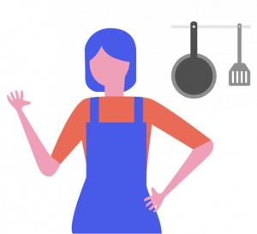**Fictional:** Nivi

**Occupation:**  Unemployed

**Demographics:**

* 51 years old
* Lives in Austin Texas with her 57 year old husband
* Has two daughters, living in other states separately;
* Has to low-income level.

**Goals and needs**

* Nivi uses online banking primarily for checking whether payments from her daughters reached her banking account .she doesn’t need any additional online banking services ,as it is often too difficult for her to get how to use them.
* However, the women would like to keep track of her expenses to put some money aside

**Pain points**

Nivi doesn’t always have a stable internet connection on her smartphones. besides, she struggles with using complicated apps worth many features , providing no explanation or tutorial .

**Relevant patterns of behavior**

Nivi is not tech-savvy.so she rarely uses her smartphone for surfing the internet -it takes her up to an hour per day. She is comfortable with browsing the web and doing simple tasks like googling something or logging in.

The women rarely uses mobile apps and prefers mobile versions of websites or her pc when going about something more complicated . marry only. the online banking service desktop version to manage payments from her daughters.

She rarely makes payments online or uses her credit card instead, the women prefers withdrawing cash and using it to pay for groceries or medicine.

**Personality**

I’m not into all the modern technologies . I prefer something reliable and easy -to-understand.”